Loosely typed => Can be number.. then string.. whatever.

**Pointers of const cannot be changed.**

Var is function-scoped..

**Let is lexical**.. limited in **scope to the block, statement, or expression**..

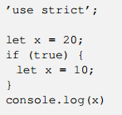

Here.. it is 20.. because it is in that block.. var would be 10..

**The value let points to can be changed**..

Const: **Can‘t change the value the pointer points to, CAN CHANGE THE OBJECT IT POINTS TO IF IT IS MUTABLE.**

Objects are mutable.

Strings are **IMMUTABLE**, number is **IMMUTABLE**.